Dear Participant of the ISRACE 2017, Greetings

We wish all the participants a safe journey and a pleasant stay in Chennai, India especially in the conference city, Chennai.

Chennai, on the Bay of Bengal in eastern India, is the capital of the state of Tamil Nadu. The city is home to Fort St. George, built in 1644 and now a museum showcasing the city’s roots as a British military garrison and East India Company trading outpost, when it was called Madras. Religious sites include the tomb of St Thomas apostle, Kapaleeshwarar Temple, adorned with carved and painted gods, St. Mary’s, a 17th-century Anglican Church and other sites around are Mahapalipuram, Kanchipuram, Vedanthangal etc.

Kindly note the following points.

# Transportation from the Airport:

Many of you have booked your accommodation as per your preference in specific hotels in Chennai near to the conference location. Some hotels do not provide the pickup facility; hence you can travel from the airport to your respective hotels with a cab facility available in the airport or You can use OLA app for cab booking. The distance from the airport to the respective hotels will be less than 10 kms. The travel time will be around 20-30 minutes. In case you find any difficulty please call us the following numbers. They will charge around Rs.300-500 from the airport to your respective hotels at Chennai.

If you face any problem kindly contact the following numbers,

Conference accommodation:

Moses Inbaraj – 9444442362, Kalarani - 9444181694, Gokul – 9840417187

# Transportation from the hotels to the conference venue (MCC)

Every day the Symposium starts at 9.00am and ends by 6:30pm. Hence the organizers of the symposium have arranged transportation from the hotels to the Madras Christian College. In case you are accommodated at MCC guest house which is inside the campus of the college and conference venue will be walkable distance of 5-10 minutes. Sign boards will be placed on the either side of the road. Your pick-up time will be at 8:00am. Everyday taxi will arrive at your hotel between 8.00 to 8:15am to take you to the symposium venue. If your accommodation is with complimentary breakfast, you can have it in your hotel.

The sessions will start at 9:00am. If you miss the transit buses and find difficulty in transportation, you can avail the cabs available in your hotel desk. The cab facility which will cost you around Rs.150-200. If you stay at Zone International Hotel, or Harishetra- sun hotel the cost will be around Rs. 200- 300.

# Transportation from the Railway Station

Those who are coming by trains you will be reaching Chennai Central or Chennai Egmore which is the last destination at Chennai.

* If you arrive at Chennai Egmore, you can easily catch the local sub-urban train from Chennai to Tambaram. Charge of the local train fare is Rs.10.
* If you arrive at Chennai Central, you have to come out of the station and cross the road through subway and catch the local train at Park Station. Take train to Tambaram. Charge of the local train fare is Rs.10. You will reach Tambaram in 45min. time. In Tambaram station, take overhead bridge and come out of the station towards East Tambaram side. , it will be a walk able distance of 10-15 minutes to reach the sypomsium venue or MCC guest house. If you avail a cab facility from Chennai Central or Chennai Egmore, the charges will be around Rs.500. Those who are arriving in the night between 11pm to 5 am, you can use the cab facility. OR Contact us for your assistance to arrange transportation for you.

# Climate

The temperature in November will be between 78°F - 86°F. The weather will be slightly windy and with occasional rains since it is the monsoon season. Hence we request you to bring light raincoats. Umbrellas can be purchased, if necessary.

# Map

A map that indicates the location of hotels, the conference venue and the routes is provided as attachment. Layout map of the conference venue is also attached for your reference.

The local people speak in Tamil. However they will understand if you speak in slow English

# General Instructions for Presentations

**For Oral Presentation: Kindly prepare your platform presentation in Microsoft Powerpoint slides. OP is limited to maximum of 10minutes including the question time.**

**Poster Presentation: The poster size should be of the dimension 3ft width x 4ft Height height (portrait mode). Poster Boards, pins will be provided**.

Looking forward to meet you in Chennai, India

With wishes

# R.Moses Inbaraj

**Organising Secretary - ISRACE 2017.**

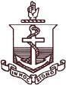Email : israce2017@gmail.com

Madras Christian College Tambaram, Chennai 600059, India

Ph: +91-9444442362 (mobile)

**Chennai Airport to Tambaram**

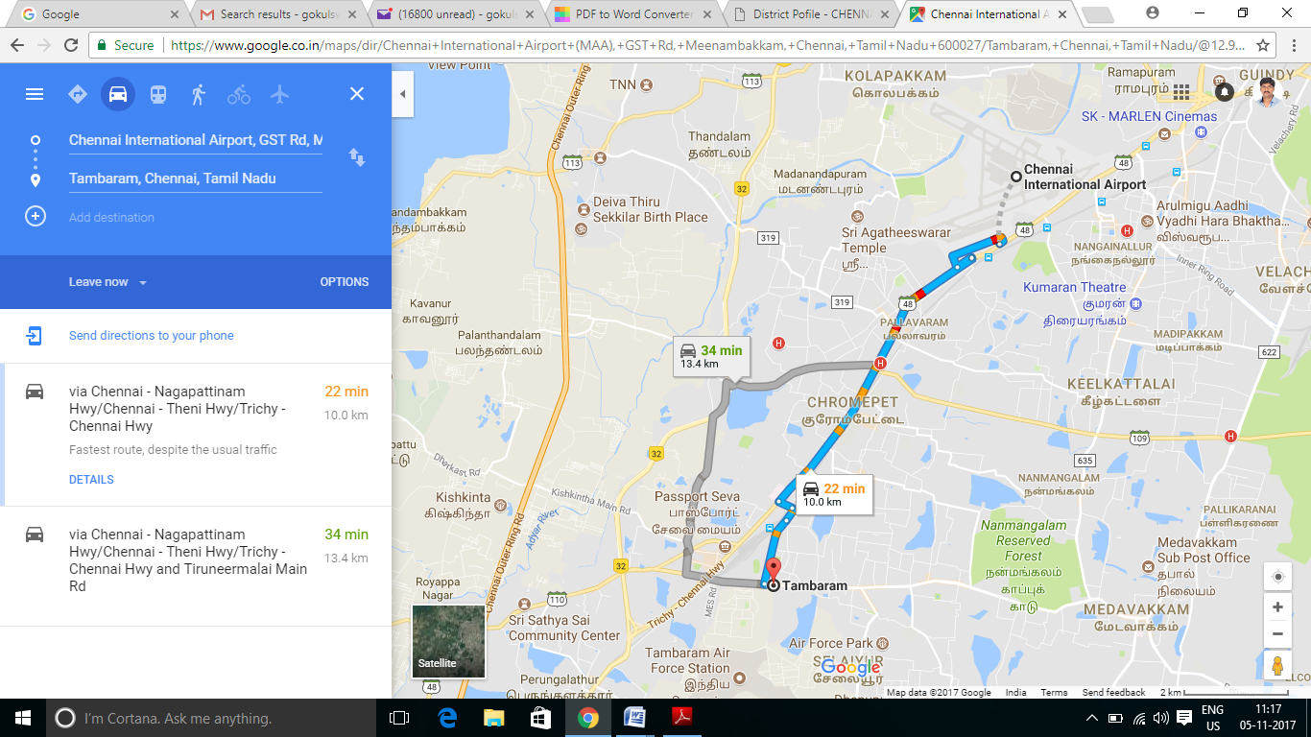

4

**Thirusulam**

**MCC**

**Chennai Central to Tambaram**

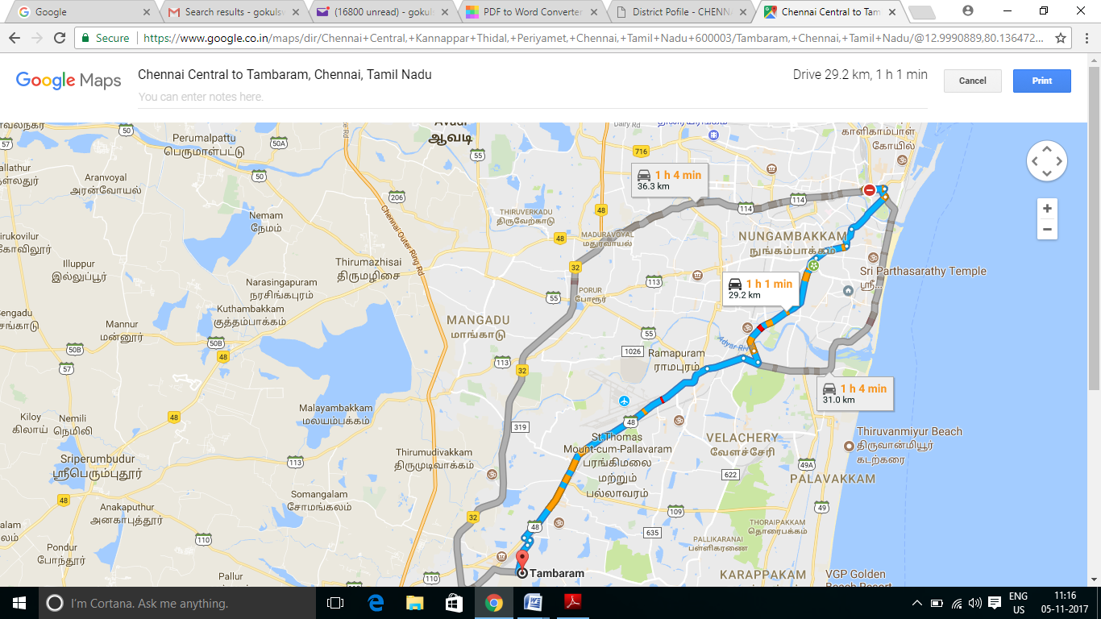

Park

Chennai Central

**Zone**

**Hotel**

**\***

**Airport**

Egmore

**MCC**